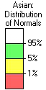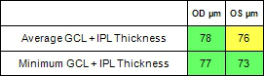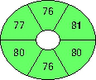

|  |  |  |  |  |  |  |  |  |  |  |  |  |  |  |  |
| --- | --- | --- | --- | --- | --- | --- | --- | --- | --- | --- | --- | --- | --- | --- | --- |
| Name: |  | | Exam Date: | | | **OD** | | | | | | **OS** | CZMI |  | |
| ID: | 10/20/2023 | | | | | | 10/20/2023 |
| DOB: | Exam Time: | | | 9:56 AM | | | | | | 9:57 AM |
| Gender: | Serial Number: | | | 5000-19931 | | | | | | 5000-19931 |
| Male | |
| Technician: | Operator, Cirrus | Signal Strength: | | | | 10/10 | | | | 10/10 | | | | | |
| **Ganglion Cell OU Analysis: Macular Cube 512x128** | | | | | | | | | | | | | | **OD** | **OS** |
| OD Thickness Map | | OS Thickness Map | | | | | | | | | | | | | |
|  | | | | |  | | | | | |  | | | | |
| Fovea: 247, 68 | | Fovea: 254, 66 | | | | | | | | | | | | | |
| OD Deviation Map | | OD Sectors | | | | | OS Sectors | | | | | | | OS Deviation Map | |
|  | | | | | | |
|  | |  | |
| OD Horizontal B-Scan | | **BScan:** | | 68 | | | | OS Horizontal B-Scan | | | | | | **BScan:** | 66 |
|  | | | | | | | | |  | | | | | | |
| Comments | | Doctor's Signature | | | | | | | | | | | | OCT5000 | |
| SW Ver: 11.0.0.29946 | |

Copyright 2018   
Carl Zeiss Meditec, Inc   
All Rights Reserved

Page 1 of 1

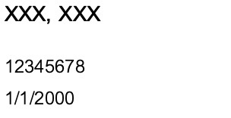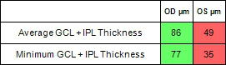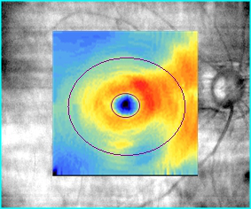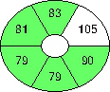

|  |  |  |  |  |  |  |  |  |  |  |  |  |  |  |  |
| --- | --- | --- | --- | --- | --- | --- | --- | --- | --- | --- | --- | --- | --- | --- | --- |
| Name: | **BOONTHAM, SAKDA** | Exam Date: | | **OD** | | | | | | | | **OS** | CZMI |  | |
| ID: | 42197120 | 10/20/2023 | | | | | | | | 10/20/2023 |
| DOB: | 5/6/1959 | Exam Time: | | 2:24 PM | | | | | | 2:26 PM | | | | | |
| Gender: | Male | Serial Number: | | | 5000-19931 | | | | | | | 5000-19931 | | | |
| Technician: | Operator, Cirrus | Signal Strength: | | | 6/10 | | | | 4/10 | | | | | | |
| **Ganglion Cell OU Analysis: Macular Cube 512x128** | | | | | | | | | | | | | | **OD** | **OS** |
| OD Thickness Map | | OS Thickness Map | | | | | | | | | | | | | |
|  | | | | | | | | | | |  | | | | |
| Fovea: 259, 66 | | Fovea: 214, 63 | | | | | | | | | | | | | |
| OD Deviation Map | | OD Sectors | | | | OS Sectors | | | | | | | | OS Deviation Map | |
|  | | | | | | | |
|  | |  | |
| OD Horizontal B-Scan | | **BScan:** | 66 | | | | OS Horizontal B-Scan | | | | | | | **BScan:** | 63 |
|  | | | | | | | |  | | | | | | | |
| Comments | | Doctor's Signature | | | | | | | | | | | | OCT5000 | |
| SW Ver: 11.0.0.29946 | |

Copyright 2018   
Carl Zeiss Meditec, Inc   
All Rights Reserved

Page 1 of 1

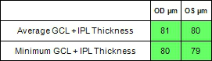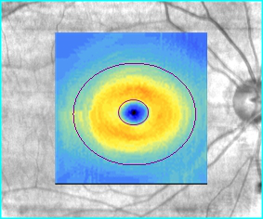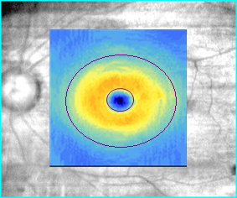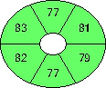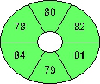

|  |  |  |  |  |  |  |
| --- | --- | --- | --- | --- | --- | --- |
| Name: |  | Exam Date: | **OD** | **OS** | CZMI |  |
| ID: | 10/20/2023 | 10/20/2023 |
| DOB: | Exam Time: | 9:15 AM | 9:17 AM | **OD** | **OS** |
| Gender: | Serial Number: | 5000-19931 | 5000-19931 |
| Female |
| Technician: | Operator, Cirrus | Signal Strength: | 8/10 | 8/10 |
| **Ganglion Cell OU Analysis: Macular Cube 512x128** | | | | |
| OD Thickness Map | | | | | OS Thickness Map |

|  |  |  |  |  |  |  |
| --- | --- | --- | --- | --- | --- | --- |
|  | | | | | | |
| Fovea: 265, 68 | Fovea: 264, 66 | | | | | |
| OD Deviation Map | OD Sectors | | | OS Sectors | OS Deviation Map | |
|  |  | | | | | |
| OD Horizontal B-Scan | **BScan:** | 68 | OS Horizontal B-Scan | | **BScan:** | 66 |
|  | | | |  | | |
| Comments | Doctor's Signature | | | | OCT5000 | |
| SW Ver: 11.0.0.29946 | |

Copyright 2018   
Carl Zeiss Meditec, Inc   
All Rights Reserved

Page 1 of 1

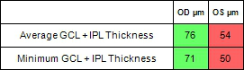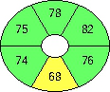

|  |  |  |  |  |  |  |  |  |  |  |  |  |  |  |  |
| --- | --- | --- | --- | --- | --- | --- | --- | --- | --- | --- | --- | --- | --- | --- | --- |
| Name: | **CHANTAJANAN, THANIT** | | Exam Date: | | **OD** | | | | | | | **OS** | CZMI |  | |
| ID: | 45033679 | | 10/20/2023 | | | | | | | 10/20/2023 |
| DOB: | 6/25/1941 | Exam Time: | | | 11:16 AM | | | | | | 11:17 AM | | | | |
| Gender: | Male | Serial Number: | | | | 5000-19931 | | | | | | 5000-19931 | | | |
| Technician: | Operator, Cirrus | Signal Strength: | | | | 7/10 | | | | 8/10 | | | | | |
| **Ganglion Cell OU Analysis: Macular Cube 512x128** | | | | | | | | | | | | | | **OD** | **OS** |
| OD Thickness Map | | OS Thickness Map | | | | | | | | | | | | | |
|  | | | | |  | | | | | |  | | | | |
| Fovea: 245, 65 | | Fovea: 252, 65 | | | | | | | | | | | | | |
| OD Deviation Map | | OD Sectors | | | | | OS Sectors | | | | | | | OS Deviation Map | |
|  | | | | | | |
|  | |  | |
| OD Horizontal B-Scan | | **BScan:** | | 65 | | | | OS Horizontal B-Scan | | | | | | **BScan:** | 65 |
|  | | | | | | | | |  | | | | | | |
| Comments | | Doctor's Signature | | | | | | | | | | | | OCT5000 | |
| SW Ver: 11.0.0.29946 | |

Copyright 2018   
Carl Zeiss Meditec, Inc   
All Rights Reserved

Page 1 of 1

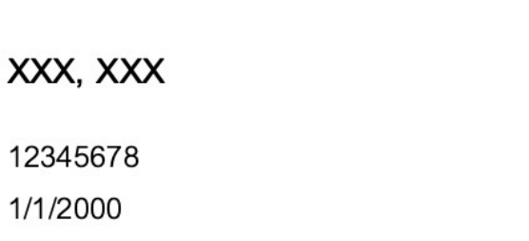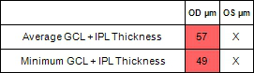

|  |  |  |  |  |  |  |
| --- | --- | --- | --- | --- | --- | --- |
| Name: | **CHOKWAN-AMNUEY, SOMSAK** | | **OD** | CZMI | **OD** |  |
| ID: | 42055001 | Exam Date: | 10/20/2023 |
| DOB: | 1/1/1940 | Exam Time: | 10:46 AM | **OS** |
| Gender: | Male | Serial Number: | 5000-19931 |
| Technician: | Operator, Cirrus | Signal Strength: | 6/10 |
| **Ganglion Cell OU Analysis: Macular Cube 512x128** | | | |

|  |  |
| --- | --- |
| OD Thickness Map |  |

|  |  |  |  |
| --- | --- | --- | --- |
| Fovea: 243, 66 | | | OCT5000  SW Ver: 11.0.0.29946 |
| OD Deviation Map | OD Sectors | |
| OD Horizontal B-Scan | **BScan:** | 66 |
|  | | |
| Comments | Doctor's Signature | |

Copyright 2018   
Carl Zeiss Meditec, Inc   
All Rights Reserved

Page 1 of 1

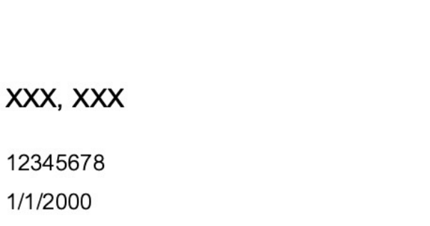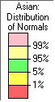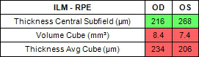

|  |  |  |  |  |  |  |  |  |  |  |
| --- | --- | --- | --- | --- | --- | --- | --- | --- | --- | --- |
| Name: | **FUFUANGSOMBAT, WANWALEE** | | **OD** | | | **OS** | | CZMI |  | |
| ID: | 38180635 | Exam Date: | 10/20/2023 | | | 10/20/2023 | |
| DOB: | 12/25/1968 | Exam Time: | 12:07 PM | | 12:09 PM | | | | | |
| Gender: | Female | Serial Number: | 5000-19931 | | | 5000-19931 | | | | |
| Technician: | Operator, Cirrus | Signal Strength: | 6/10 | 7/10 | | | | | | |
| **Macula Thickness OU: Macular Cube 512x128** | | | | | | | | | **OD** | **OS** |
| OD ILM-RPE Thickness Map | | | OS ILM-RPE Thickness Map | | | | | | | |
|  | | |  | | | |  | | | |
| Fovea: 254, 70 | | | Fovea: 244, 68 | | | | | | | |
| OD OCT Fundus | | OD ILM-RPE Thickness | OS ILM-RPE Thickness | | | | | | OS OCT Fundus | |
|  | |  |  | | | | | |  | |
| OD Horizontal B-Scan **BScan:** 70 | | | OS Horizontal B-Scan **BScan:** 68 | | | | | | | |
| Comments | | Doctor's Signature | | | | | | | OCT5000 | |
| SW Ver: 11.0.0.29946 | |

Copyright 2018   
Carl Zeiss Meditec, Inc   
All Rights Reserved

Page 1 of 1

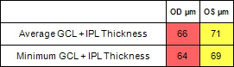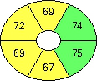

|  |  |  |  |  |  |  |  |  |  |  |  |  |  |  |  |  |
| --- | --- | --- | --- | --- | --- | --- | --- | --- | --- | --- | --- | --- | --- | --- | --- | --- |
| Name: | Male | | | | Exam Date: | | | **OD** | | | | | **OS** | CZMI |  | |
| ID: | 10/20/2023 | | | | | 10/20/2023 |
| DOB: | Exam Time: | | | 10:33 AM | | | | | 10:37 AM |
| Gender: | Serial Number: | | | 5000-19931 | | | | | 5000-19931 |
| Technician: | Operator, Cirrus | | | Signal Strength: | | | | 9/10 | | | 9/10 | | | | | |
| **Ganglion Cell OU Analysis: Macular Cube 512x128** | | | | | | | | | | | | | | | **OD** | **OS** |
| OD Thickness Map | | | | | | | OS Thickness Map | | | | | | | | | |
|  | | | | | | |  | | | | |  | | | | |
| Fovea: 250, 64 | | | | | | | Fovea: 245, 64 | | | | | | | | | |
| OD Deviation Map | | OD Sectors | | | | | OS Sectors | | | | | | | | OS Deviation Map | |
|  | | | | |
|  | |  | |
| OD Horizontal B-Scan | | | **BScan:** | | | 64 | | | OS Horizontal B-Scan | | | | | | **BScan:** | 64 |
|  | | | | | | | | | |  | | | | | | |
| Comments | | | | | | | Doctor's Signature | | | | | | | | OCT5000 | |
| SW Ver: 11.0.0.29946 | |

Copyright 2018   
Carl Zeiss Meditec, Inc   
All Rights Reserved

Page 1 of 1

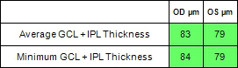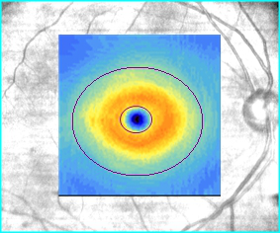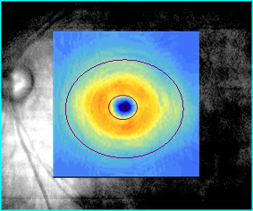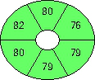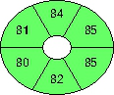

|  |  |  |  |  |  |  |  |  |  |  |  |  |  |  |
| --- | --- | --- | --- | --- | --- | --- | --- | --- | --- | --- | --- | --- | --- | --- |
| Name: |  | | | Exam Date: | | **OD** | | | | | **OS** | CZMI |  | |
| ID: | 10/20/2023 | | | | | 10/20/2023 |
| DOB: | Exam Time: | | 12:02 PM | | | | | 12:03 PM |
| Gender: | | Female | | Serial Number: | | | 5000-19931 | | | | 5000-19931 | | | |
| Technician: | | | Operator, Cirrus | Signal Strength: | | | 9/10 | | | 6/10 | | | | |
| **Ganglion Cell OU Analysis: Macular Cube 512x128** | | | | | | | | | | | | | **OD** | **OS** |
| OD Thickness Map | | | | OS Thickness Map | | | | | | | | | | |
|  | | | |  | | | | | | | | | | |
| Fovea: 247, 68 | | | | Fovea: 248, 67 | | | | | | | | | | |
| OD Deviation Map | | | | OD Sectors | | | | | OS Sectors | | | | OS Deviation Map | |
|  | | | |  | | | | | | | | | | |
| OD Horizontal B-Scan | | | | **BScan:** | 68 | | | OS Horizontal B-Scan | | | | | **BScan:** | 67 |
|  | | | | | | | | |  | | | | | |
| Comments | | | | Doctor's Signature | | | | | | | | | OCT5000 | |
| SW Ver: 11.0.0.29946 | |

Copyright 2018   
Carl Zeiss Meditec, Inc   
All Rights Reserved

Page 1 of 1

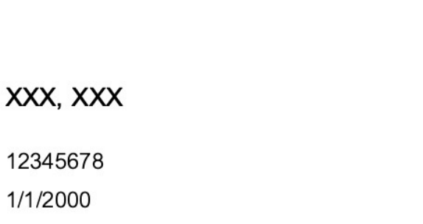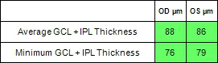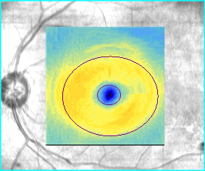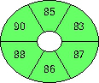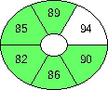

|  |  |  |  |  |  |  |  |  |  |  |  |  |  |  |  |  |  |  |
| --- | --- | --- | --- | --- | --- | --- | --- | --- | --- | --- | --- | --- | --- | --- | --- | --- | --- | --- |
| Name: | **KWANGKEEREE, SUTHAT** | | | | | | Exam Date: | | **OD** | | | | | | **OS** | CZMI |  | |
| ID: | 46092436 | | | | | | 10/20/2023 | | | | | | 10/20/2023 |
| DOB: | 8/27/1952 | | | Exam Time: | | | | | 9:28 AM | | | | | 9:30 AM | | | | |
| Gender: | Male | Serial Number: | | | | | | | | 5000-19931 | | | | | 5000-19931 | | | |
| Technician: | Operator, Cirrus | | | | | Signal Strength: | | | | 9/10 | | | 8/10 | | | | | |
| **Ganglion Cell OU Analysis: Macular Cube 512x128** | | | | | | | | | | | | | | | | | **OD** | **OS** |
| OD Thickness Map | | | | | | | | | OS Thickness Map | | | | | | | | | |
|  | | | | | | | | |  | | | | | | | | | |
| Fovea: 255, 63 | | | | | | | | | Fovea: 274, 74 | | | | | | | | | |
| OD Deviation Map | | | OD Sectors | | | | | | OS Sectors | | | | | | | | OS Deviation Map | |
|  | | | | | | | | |  | | | | | | | | | |
| OD Horizontal B-Scan | | | | | **BScan:** | | | 63 | | | OS Horizontal B-Scan | | | | | | **BScan:** | 74 |
|  | | | | | | | | | | | |  | | | | | | |
| Comments | | | | | | | | | Doctor's Signature | | | | | | | | OCT5000 | |
| SW Ver: 11.0.0.29946 | |

Copyright 2018   
Carl Zeiss Meditec, Inc   
All Rights Reserved

Page 1 of 1

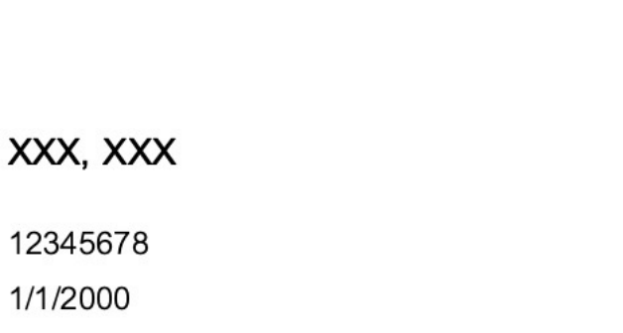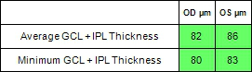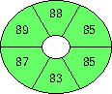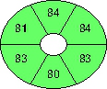

|  |  |  |  |  |  |  |  |  |  |  |  |  |  |  |  |  |  |  |
| --- | --- | --- | --- | --- | --- | --- | --- | --- | --- | --- | --- | --- | --- | --- | --- | --- | --- | --- |
| Name: | **KHAIKHUNTHOD, JANJIRA** | | | | | Exam Date: | | **OD** | | | | | | | **OS** | CZMI |  | |
| ID: | 54454162 | | | | | 10/20/2023 | | | | | | | 10/20/2023 |
| DOB: | 1/16/1990 | | Exam Time: | | | | | 9:52 AM | | | | | 9:53 AM | | | | | |
| Gender: | Female | Serial Number: | | | | | | | 5000-19931 | | | | | | 5000-19931 | | | |
| Technician: | Operator, Cirrus | | | | Signal Strength: | | | | 10/10 | | | 10/10 | | | | | | |
| **Ganglion Cell OU Analysis: Macular Cube 512x128** | | | | | | | | | | | | | | | | | **OD** | **OS** |
| OD Thickness Map | | | | | | | | OS Thickness Map | | | | | | | | | | |
|  | | | | | | | |  | | | | | |  | | | | |
| Fovea: 246, 64 | | | | | | | | Fovea: 254, 65 | | | | | | | | | | |
| OD Deviation Map | | OD Sectors | | | | | | OS Sectors | | | | | | | | | OS Deviation Map | |
|  | | | | | | | |  | | | | | | | | | | |
| OD Horizontal B-Scan | | | | **BScan:** | | | 64 | | | OS Horizontal B-Scan | | | | | | | **BScan:** | 65 |
|  | | | | | | | | | | |  | | | | | | | |
| Comments | | | | | | | | Doctor's Signature | | | | | | | | | OCT5000 | |
| SW Ver: 11.0.0.29946 | |

Copyright 2018   
Carl Zeiss Meditec, Inc   
All Rights Reserved

Page 1 of 1